Forum: The Disarmament and International Security Commission
Topic: Question of the creation to create a nuclear weapons free zone
Student Officer: Lee Phei Shan
Position: Deputy President of the Disarmament and International Security Commission (DISEC)
_________________________________________________________________________

Profile of the Deputy President
Greetings esteemed delegates! My name is Lee Phei Shan. I am 15 years old and I am currently a student of SMK Bandar Utama Damansara (4). At the age of 13 in 2012, I began to indulge in MUN and ever since then, I’ve enjoyed attending MUN conferences. TISMUNKL will be my 10th conference but my first time chairing and it would be an understatement to say that I am excited to work with each and every one of you. Good luck with research and preparation for this conference, or as Suzanne Collins would say, “May the odds be ever in your favour”. Should you have any queries, please do not hesitate to contact me at pheishan888@gmail.com and I will do my level best to help you. See you soon!

History of the Committee
The Disarmament & International Security (DISEC) committee is the First Committee of six main committees at the United Nations General Assembly. Its mandate is to promote the establishment and maintenance of international peace and security with the least diversion for armaments of the world’s human and economic resources.

Statement of the Problem
A nuclear weapon is defined as an explosive device that derives its destructive force from nuclear reactions, either fission or a combination of fission and fusion. Nuclear weapons are considered weapons of mass destruction, and their use and control have been a major focus of international relations policy since their debut. The several nations that have been known to possess such weapons and that acknowledge said possession are the United States, the Soviet Union, the United Kingdom, France, the People’s Republic of China, India, Pakistan and North Korea. Israel is widely believed to possess nuclear weapons but denies possession of them.

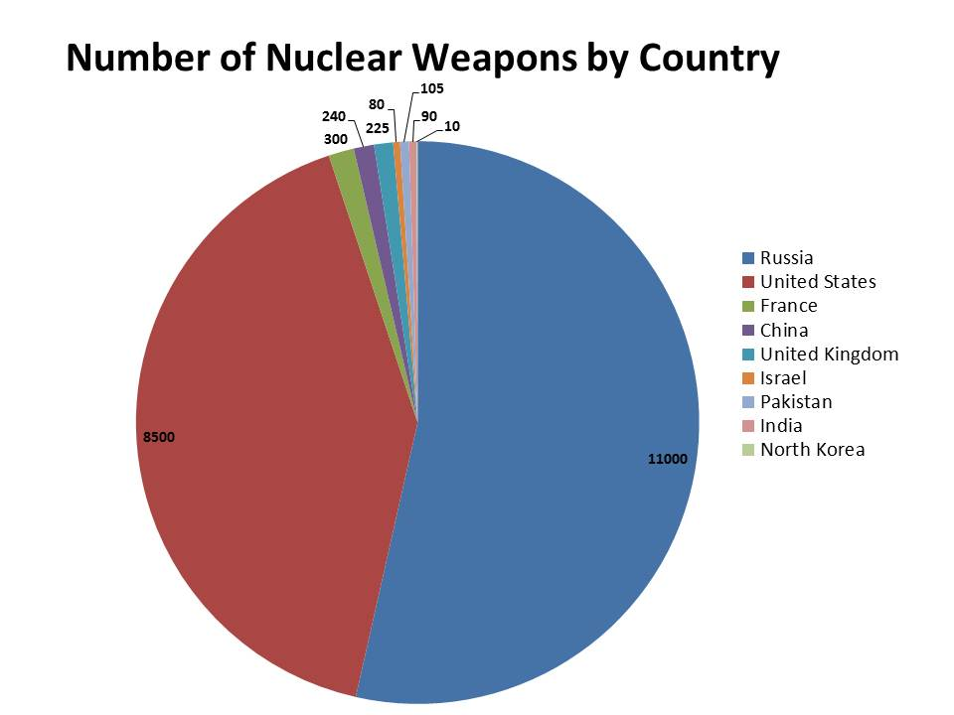
Source : http://www.huffingtonpost.com/howard-steven-friedman/countries-with-nuclear-weapons_b_1189632.html
The Current Situation
A nuclear-weapons-free zone (NWFZ) is defined by the United Nations as an agreement in which several member states has freely established by either treaty or convention, that bans the use, development, or deployment of nuclear weapons that is recognized as such by the General Assembly of the United Nations. Another term, nuclear-free zone, often means an area which has banned both nuclear power and nuclear weapons, and sometimes nuclear waste and nuclear propulsion, and usually does not mean a UN-acknowledged international treaty.
To date, although nuclear weapons have only been used twice in warfare—in the bombings of Japanese cities, Hiroshima and Nagasaki by the United States during the final stages of World War II in August 1945—about 22,000 reportedly remain in our world today and there have been over 2,000 nuclear tests conducted to date. Disarmament is the best protection against such

dangers, but achieving this goal has been a tremendously difficult challenge.
National security threats may be divided into three major categories: major power conflicts, such as those involving United States, Russia and China; regional conflicts, including potential nuclear states such as Iran, Iraq, or North Korea; and conflicts involving terrorist groups and other non-state organizations.
A number of multilateral treaties have since been established with the aim of preventing nuclear proliferation and testing, while promoting progress in nuclear disarmament. These include the Treaty on the Non-Proliferation of Nuclear Weapons (NPT), the Treaty Banning Nuclear Weapon Tests In The Atmosphere, In Outer Space And Under Water, also known as the Partial Nuclear Test Ban Treaty (PTBT), and the Comprehensive Nuclear-Test-Ban Treaty (CTBT).
The nuclear tests of India and Pakistan, both in 1998 is proof that countries may act in their own perceived national interests, sometimes in direct opposition to the wishes of the previous treaty commitments or arrangements. North Korea is presumed to have nuclear capability and has demonstrated remarkable progress in ballistic missile technology. Japan and South Korea look upon North Korea’s nuclear ambitions with concern and could pursue their own nuclear programs if they felt uncertainty in the security and interests of their nation. Nuclear engagement scenarios are not necessarily binary. Third countries may feel compelled to intervene in disputes between nuclear states or in conflicts involving weapons of mass destruction that could spill over into their territory or interests. For example, China may feel a need to act in a nuclear exchange between India and Pakistan.
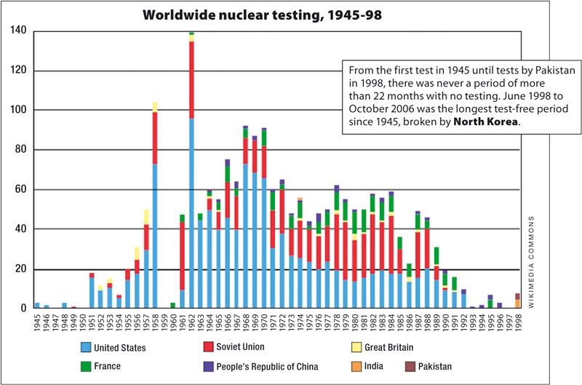
Source : http://newint.org/features/2008/06/01/nuclear-weapons-facts/

The evolution of new regional threats to international security and the stated desire of many countries to reduce or eliminate their nuclear arsenals suggest that the time is right for a fundamental rethinking of the role of nuclear weapons in national security.

Definition of Key Terms
World War II
A global war which is generally considered to have lasted from 1939 to 1945, that involved more than 100 million people, from more than 30 different countries.
Regional conflicts
A war requiring violation of the territorial sovereignty of two or more nation states.
Multilateral treaties
A treaty to which three or more sovereign states are parties. Each party owes the same obligations to all other parties, except to the extent that they have stated reservations.
Nuclear proliferation
The spread of nuclear weapons.
Non-Proliferation Treaty
An international treaty whose objective is to prevent the spread of nuclear weapons and weapons technology, to promote cooperation in the peaceful uses of nuclear energy and to further the goal of achieving nuclear disarmament.
Partial Test Ban Treaty (PTBT)
A treaty prohibiting all test detonations of nuclear weapons except underground.
Ballistic missile
A missile (rocket) that follows a ballistic flight path with the objective of delivering one or more warheads to a predetermined target.
Weapons of mass destruction
A nuclear, radiological, biological, chemical or other weapon that can kill and bring significant harm to a large number of humans or cause great damage to man-made structures (e.g. buildings), natural structures (e.g. mountains), or the biosphere.

Timeline of Events

Date | Description of Events
6 August 1945 | US drops a uranium bomb over the Japanese city of Hiroshima.
9 August 1945 | US detonates a plutonium bomb over Nagasaki.
24 January 1946 | UN calls for elimination of atomic weapons.
29 August 1949 | Soviet Union tests its first nuclear bomb.
1 December 1959 | The Antarctic Treaty was established.
13 February 1960 | France tests its first nuclear weapon.
5 August 1963 | Partial Test Ban Treaty opens for signature.
1 July 1968 | Non-Proliferation Treaty is signed.
10 July 1991 | South Africa joins Non-Proliferation Treaty.
May 1998 | India and Pakistan conduct nuclear tests.  - India conducts three underground nuclear tests.  - Pakistan tested six nuclear weapons in response to India’s tests.
9 October 2006 | North Korea conducts nuclear test.

Relevant International Efforts/Past UN Actions
- 1996 Comprehensive Nuclear-Test-Ban Treaty (CTBT)
- Treaty on the Non-Proliferation of Nuclear Weapons
- Nuclear Security Summit
- Campaign for Nuclear Disarmament
- Security Council Resolution 1887

Possible Solutions
Delegates should tackle the topic at hand from perspectives such as the role of nuclear weapons in maintaining national security, studying past efforts that have been taken as well as treaties that have been established and the countries which are signatories to those treaties. Also, detection and deterrence of illicit trafficking in nuclear materials is an angle to this topic that could be enhanced with international partnerships.
Secondly, delegates should consider immediate actions to be taken on countries that have not agreed to nuclear weapon disarmament by ways such as facilitating multilateral talks, altering the perception of nations that store nuclear weapons as a means of protecting their military interests, while bearing in mind that the sovereignty of each country should not be breached. The role of the IAEA in undertaking regular inspections of civil nuclear facilities and auditing the movement of nuclear materials through them should be given due consideration.
Moving on, measures should be taken to address the fact that many nations are reluctant to ban the use of nuclear weapons as major power nations which still possess nuclear weapons pose a threat to their security and hence, the need to strengthen trust and cooperation between member states is a vital step towards creating a nuclear weapons free zone.

References
- http://www.icanw.org/
- http://www-ns.iaea.org/
- http://en.wikipedia.org/wiki/Atomic_bombings_of_Hiroshima_and_Nagasaki
- http://www.un.org/disarmament/WMD/Nuclear/NWFZ.shtml
- http://en.wikipedia.org/wiki/List_of_states_with_nuclear_weapons
- http://news.bbc.co.uk/onthisday/hi/dates/stories/may/28/newsid_2495000/2495045.stm
- http://newint.org/features/2008/06/01/nuclear-weapons-facts/

––

