Forum: The Disarmament and International Security Commission
Topic: Threats to international peace and security caused by terrorist acts
Student Officer: Priscilla Lim
Position: President of the Disarmament and International Security Commission (DISEC)
_________________________________________________________________________

Profile of the President
Hello! I am Priscilla Lim & I will be serving as the chair of the DISEC committee at TISMUNKL 2014. Studying in SMK Bandar Utama Damansara (4), I am 17-years-old & am completing my final year in high school. I started doing MUN in 2010 & am currently the Co-President of BUD(4)MUN. I have attended over 10 conferences & have had a hand at chairing once. I am really looking forward to meeting all of you & working with you at the conference!

History of the Committee
The Disarmament & International Security (DISEC) committee is the First Committee of six main committees at the United Nations General Assembly. Its mandate is to promote the establishment and maintenance of international peace and security with the least diversion for armaments of the world’s human and economic resources.

Statement of the Problem
Terrorism is typically defined as the use of violence and intimidation in the pursuit of political aims. Although terrorist-like actions have existed since the 1st century, there has not been a precise definition of terrorism which is legally binding in the international law. However, in November 2004, UN Secretary General at that time, Kofi Annan described terrorism as an act “intended to cause death or serious bodily harm to civilians or non-combatants with the purpose of intimidating a population or compelling a government or an international organization to do or abstain from doing any act.” Terrorism leads to a large number of deaths at a time & also negatively affects a country’s economy.

The Current Situation
In the 21st century, terrorism has reached new heights. The 9-11 attacks on September 11th 2001 that hit New York & Washington D.C. shook the world & caused nearly 3000 deaths clearly showed us the threats of terrorism. There are many terrorist groups today, however, it is up to each individual country to designate a particular group as a terrorist organisation. For example, some of these groups could be perceived merely as rebel groups who are fighting for freedom & their rights. This is where the importance of defining terrorism comes in to combat this problem. Therefore, it is important for delegates to know their country’s stand on certain terrorist organisations. Terrorism could be conducted by different groups of people. This act could be conducted by a non-state group, state sponsors or state terrorists themselves. (refer to definitions below) Terrorism also exists in various forms such as narcoterrorism, bioterrorism, ecoterrorism, nuclear terrorism and cyber terrorism.

Since 9-11, a new movement of al-Qaeda-inspired groups have began to unfold. This has been reportedly linked to jihadism. This movement has caused severe threat to many nations.

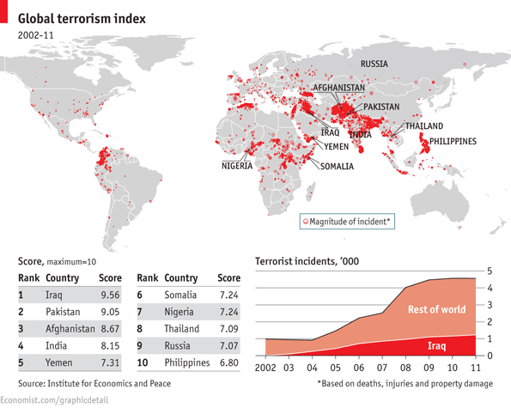
The Global Terrorism Index (GTI) is a product of the work of the Institute for Economics and Peace which is an independent, non-partisan, non-profit research organisation based in Sydney, Australia. The GTI is a measure to rank a country based on the terrorism activity during a 10-year period, & is based on data from the Global Terrorism Database (GTD). As shown above, a large percentage of terrorism occurs in the Middle East. However, nearly every region of the world has reports of terrorist attacks.

Lately, one factor that has contributed to the large number of terrorist attacks is the accessibility to weapons. Weapons of mass destruction (WMD), biological weapons, chemical weapons, & nuclear weapons are easily acquired by such groups, mostly via black markets. With such weapons, a single attack could cause massive destruction on a country. The gruesome 9-11 attacks which was conducted reportedly without any WMDs could already cause almost 3000 deaths in total.
Definition of Key Terms
Non-state groups: terrorist groups not part of the state apparatus or in opposition to the state.

State sponsors: funding or harboring a terrorist organization without acknowledging it as terrorism.

State terrorism: acts of terrorism conducted by a state against a foreign state or people or its own people.

Weapons of Mass Destruction (WMD): a chemical, biological or radioactive weapon capable of causing widespread death and destruction.

Timeline of Events
Date | Description of Events
15 December 1997 | The UN passes the International Convention for the Suppression of Terrorist Bombings.
1999 | The UN passes the International Convention for the Suppression of the Financing of Terrorism.
11 September 2001 | Four planes are hijacked & attack New York City & Washington D.C. causing nearly 3000 deaths. Al-Qaeda leader, Osama bin Laden takes responsibility.
12 September 2001 | The UN Security Council passes a resolution condemning terrorism & calls for all States to bring perpetrators to justice.
January 2003 | The UN Office of Drugs and Crime (UNODC) launches Global Project on Strengthening the Legal Regime against Terrorism.
20 March 2003 | The Iraq War begins which President George Bush refers to as “the central front in the War on Terror”, which is a U.S. campaign against terrorism.
2 May 2011 | Al-Qaeda leader, Osama bin Laden is killed by the U.S. military in Pakistan.

Relevant International Efforts/Past UN Actions
- International Convention for the Suppression of Terrorist Bombings
- International Convention for the Suppression of the Financing of Terrorism
- Security Council Resolution 1368
- Security Council Resolution 1373
- UNODC Global Project on Strengthening the Legal Regime against Terrorism
- INTERPOL’s CBRNE Terrorism Prevention Programme
- Nuclear Terrorism Convention

Possible Solutions
Defining terrorism clearly is crucial in order to rid any ambiguity in the effort to combat terrorism. The uncertainty & differing perception towards terrorism slows down the process of counter-terrorism & affects the communication between member nations & organisations in solving this issue.

Furthermore, a different approach on dealing with terrorists could be explored as the methods carried out in previous efforts have failed to fully overcome the problem. Suitable penalties should also be decided on collectively, as there has been much debate on what terrorists should face as a result of their actions. Delegates should look into carrying out efforts regionally instead of just internationally, & also using diplomacy instead of violence & force.
Delegates should study closely what among the past efforts have worked, & what clearly has not. Past efforts should be further enhanced with more cooperation among member nations & organisations.

References
- http://www.globalpolicy.org/us-un-and-international-law-8-24/un-involvement-against-terrorism.html
- http://www.unodc.org/unodc/en/terrorism/
- http://en.wikipedia.org/wiki/Terrorism
- http://www.iaea.org/
- http://www.fbi.gov/stats-services/publications/law-enforcement-bulletin/september-2011/the-evolution-of-terrorism-since-9-11
- http://www.interpol.int/Crime-areas/Terrorism/Terrorism
- http://economicsandpeace.org/research/iep-indices-data/global-terrorism-index

