Forum: The Disarmament and International Security Committee
Topic: Situation between Iraq and Kuwait
Student Officer: Priscilla Lim
Position: President of the Disarmament and International Security Commission (DISEC)
_________________________________________________________________________
Profile of the President
Hello! I am Priscilla Lim & I will be serving as the chair of the DISEC committee at TISMUNKL 2014. Studying in SMK Bandar Utama Damansara (4), I am 17-years-old & am completing my final year in high school. I started doing MUN in 2010 & am currently the Co-President of BUD(4)MUN. I have attended over 10 conferences & have had a hand at chairing once. I am really looking forward to meeting all of you & working with you at the conference!

History of the Committee
The Disarmament & International Security (DISEC) committee is the First Committee of six main committees at the United Nations General Assembly. Its mandate is to promote the establishment and maintenance of international peace and security with the least diversion for armaments of the world’s human and economic resources.

Statement of the Problem
Iraq and Kuwait are neighbouring countries in the Middle East. For a long time, Iraq had claimed the Kuwait was a part of Iraq. In 1963, Iraq finally accepted Kuwait’s borders. During the Iran-Iraq war from 1980-1988, Kuwait was in fact Iraq’s close ally. However, after the war, the relationship between the two countries was damaged.
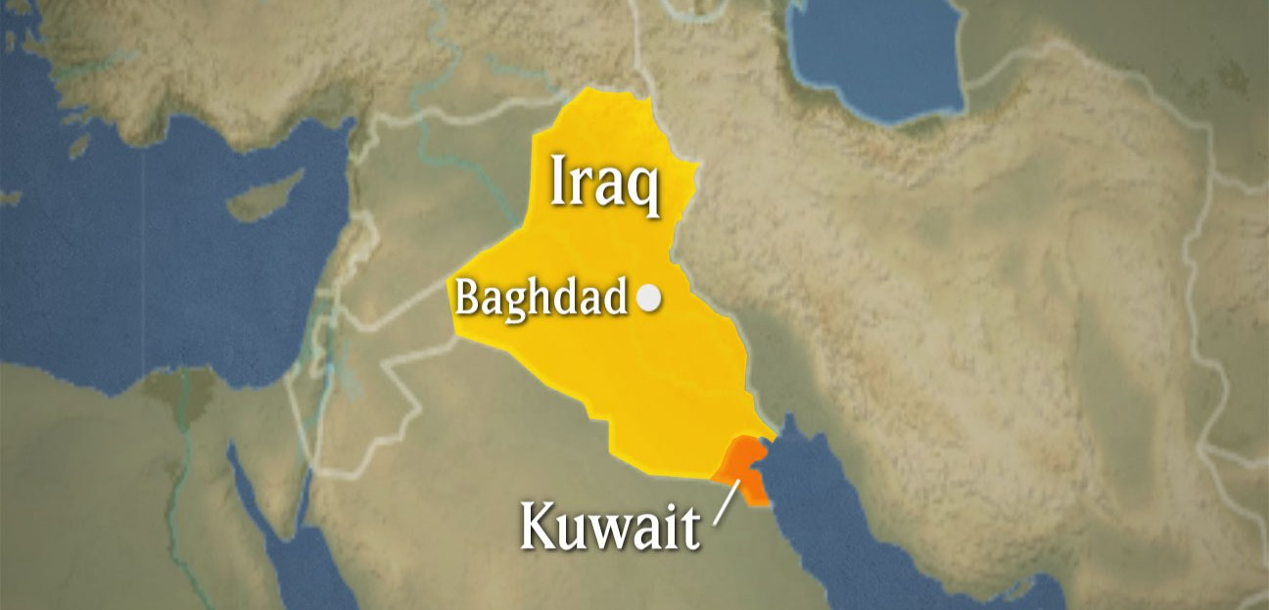
Source: http://www.sdpb.sd.gov/EducationalServicesGuide/etvprograms/tctp.asp
Kuwait had largely funded Iraq during the war, leaving Iraq in debt of US$14 billion dollars.
After the war, Iraq was not able to repay what it owed to Kuwait & had asked Kuwait to let go of the debt. Kuwait was reluctant to do as asked & tensions arose between the two countries.

To make things even worse between Iraq & Kuwait, Kuwait had explicitly gone against Iraq’s requests for the Organisation of Petroleum Exporting Countries (OPEC) to reduce the crude of production quota. Because of Kuwait’s oil strategy, Iraq lost an estimated US$14 billion dollars a year from 1985 to 1989. Iraq saw Kuwait’s actions as an act of aggression against it. Tensions increased when Kuwait allegedly crossed the border to Iraq’s Rumalia field while slant drilling, a method used to drill for oil. Iraq accused Kuwait for stealing US$2.4 billion worth of their oil, however Kuwait denied such accusations. On 25 July 1990, the OPEC & the United Arab Emirates decided to put a limit on daily oil output, that is 1.5 million barrels in order to ease the tensions between the two countries. However, their efforts were done in vain.

On 2 August 1990, Iraq launched an invasion on Kuwait which initiated the Gulf War. Within 48 hours, Iraq had taken over the whole country. The Iraqi troops burned down government buildings & houses. There were severe cases of human rights abuse, such as interrogating Kuwaiti civilians through uncivilised means like electrocution & mutilation of body parts. Approximately 1000 Kuwaitis were killed & over 300 000 civilians had to flee the country. Iraq’s actions were condemned internationally as the Security Council passed a resolution. In mid-January 1991, the United States led a coalition & launched a military attack on Iraqi forces under Operation Desert Storm. On 16 January, the Iraqi Air Force was defeated, & on 25 February 1991, Kuwait was liberated from Iraq. However, there are still hundreds of people who went missing during the war that still have not been found.

The Current Situation
Although it has been over 20 years since the Iraq-Kuwait dispute, it was only recently in 2012 that amends between the two countries started to be successful. This is because the tense relationship between them was left unresolved due to the un-cooperation of Saddam Hussein’s regime. The aforementioned regime had refused to accept the UN-declared Iraq-Kuwait border. The Iraqi government had tried to make efforts in addressing the issues in 2003 when Saddam Hussein had been captured, however, their efforts were short-lived due to the lack of trust between the nations as well as Iraq’s post-conflict recovery.
In 2012, things started to take a turn for the better when the Iraqi Prime Minister visited Kuwait to personally extend an invitation to the Emir of Kuwait to attend the Summit of the Arab League. The UN was greatly pleased & had continuously encouraged the two countries to keep working at their relationship. In May 2013, Iraq & Kuwait established a bilateral committee between themselves for the joint maintenance of the common boundary. There are still sensitive issues left unresolved such as missing Kuwaitis & property that were lost during the invasion. There is still much to be done to fully amend the relationship between the two countries.
Definition of Key Terms
Slant drilling: drilling for oil or gas in other than a vertical direction.

Invasion: an instance of invading a country or region with an armed force.

Gulf War: a war fought between Iraq and a coalition led by the United States that freed Kuwait from Iraqi invaders, 1990-1991.

Organisation of Petroleum Exporting Countries (OPEC): a multi-governmental organisation of twelve developing countries which are heavily reliant on oil revenues as their main source of income.

Timeline of Events
Date | Description of Event
24 June 1961 | Iraq demanded dominion over Kuwait.
1963 | Iraq renounced its claim toward Kuwait.
May 1990 | Saddam Hussein says that oil overproduction by Iraq & the UAE was an economic warfare towards Iraq.
22 July 1990 | Iraq started deploying troops at the Iraq-Kuwait border.
2 August 1990 | About 100 000 Iraqi troops invaded Kuwait. The UN Security Council demanded Iraq to withdraw from Kuwait immediately & unconditionally.
7 August 1990 | The United States initiates Operation Desert Storm on Iraq.
2 January 1991 | Iraqi troops begin blowing up Kuwaiti oil wells.
22 January 2991 | United States President, George W. Bush issues 24-hour ultimatum, in which Iraq must withdraw to prevent war.
26 February 1991 | Saddam Hussein orders the withdrawal of Iraqi troops from Kuwait. The Coalition of Operation Desert Storm bombs civilian & military vehicles, killing 100 000 Iraqi troops.
3 March 1991 | Iraq accept the terms of a ceasefire from the UN Security Council.
13 December 2003 | Saddam Hussein was captured by the United States military.
March 2013 | Prime Minister of Iraq, Nuri al-Maliki visits Kuwait to invite Kuwaiti Emir to the Summit of the Arab League.
May 2013 | Iraq & Kuwait form bilateral committee.

Relevant International Efforts/Past UN Actions
- United Nations Iraq-Kuwait Observation Mission (UNIKOM (1991-2003)
- Security Council Resolution 678
- Security Council Resolution 2107
- ICRC Tripartite Commission

Possible Solutions
Trust between the two countries must be rebuilt on many levels. There should be further dialogue between the nations in order to establish a new friendship. Furthermore, efforts should be taken in order to resolve the remaining issues that were caused by the invasion in 1990. Measures should also be taken in order to ensure that both the countries carry out what they both need to do for each other, such as Iraq paying its debt.

Other countries & organisation should facilitate in this. The talks between the two countries ought to be mediated, & international support should be encouraged to put this to rest once & for all. The International Committee of the Red Cross (ICRC) has been facilitating the recovery of the missing persons, & Iraq has been requested by the Security Council in Resolution 2107 to continue facilitating the efforts by providing the assistance needed.

References
- http://www.timelines.ws/countries/KUWAIT.HTML
- http://iml.jou.ufl.edu/projects/spring06/eisa/war.html
- http://www.un.org/wcm/content/site/undpa/main/enewsletter/pid/24724
- http://en.wikipedia.org/wiki/Timeline_of_the_Gulf_War
- http://en.wikipedia.org/wiki/Invasion_of_Kuwait

