Topic: Question of Military Intervention In The Russia And Ukraine Crisis

Profiles
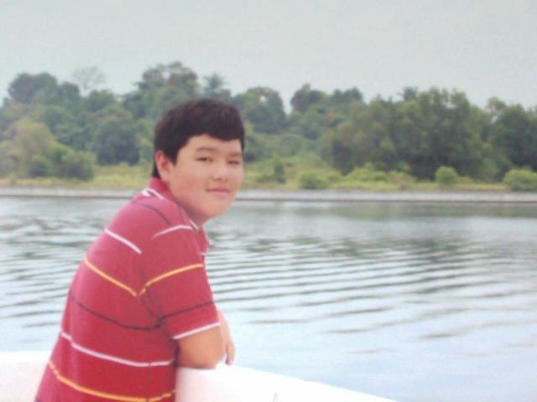
Hello everyone! My name is Kenny Ng and I am honoured to be serving as your co chair at this year’s Security Council. I am currently doing my International Baccalaureate in Nexus International School Putrajaya. I have been in the MUN circuit for almost 3 years, over 14 conferences under my belt alongside a wealth of knowledge and experience. This would be my first time chairing a Security Council and I’m eager to know what its like on the other side of the debate and I’m hoping it’ll be just as fiery and as passionate! I hope through this council delegates can understand various critical world issues as well as breed a sense of diplomacy and global spirit among delegates. With such an all stars committee, I can be rest assured that the 3 days ahead will be no short of excellence.

Brief History Of Committee

The United Nations Security Council (UNSC) is one of the six principal organs of the United Nations and is charged with the maintenance of international peace and security. Its powers include the establishment of peacekeeping operations, the establishment of international sanctions, and the authorization of military action through Security Council resolutions; it is the only UN body with the authority to issue binding resolutions to member states

Statement Of Problem

The crisis within the Ukraine Russian region started with the Ukrainian Crisis which started in February 2014. Riots occurred in Kiev, the capital of Ukraine due to civil unrest over past and current government mismanagement. Soon after, Ukrainian president, Viktor Yanukovych was impeached from parliament, causing a new interim government to be established.

On February 27th, 60 armed Russian men stormed the Crimean parliament. Russian troops began entering the Crimean peninsula soon after, establishing control within the region. Ukraine viewed such a act as a breach of sovereignty by Russia and demanded that Russian troops be pulled from the region. Russia retaliated by stating that it was merely protecting ethnic Russians within the Crimean region. The resulting conflict has resided upon the tug of war between Russian and Ukraine over the Crimean region which threatens to destabilize and aggravate the already fragile political realm.

Current Situation

Russian officials have held a referendum within the region of Crimea which has yielded results of 97% of Crimeans voting to be part of Russia. This has resulted in Russia annexing Crimea from Ukraine which has led to the aggravation conflict between both nations. Ukraine and most of the international community have condemned Russia for its skewed involvement in the referendum as well as the annexation of Crimea. Russian troops continue to be stationed in within Crimea region, with an influx of them stationed within the borders of Ukraine. Currently, there have been reports of clashes of pro Russian and local police forces as protesters have seized several administrative buildings within Donetsk which threaten to escalate tensions within the region.

Timeline Of Events

28-29 January 2014 | Prime Minister Mykola Azarov resigns and parliament annuls the anti-protest law. Parliament passes amnesty bill promising to drop charges against all those arrested in unrest if protesters leave government buildings. Opposition rejects conditions.
18 February 2014 | Clashes erupt, with reasons unclear: 18 dead, including seven police, and hundreds more wounded. Some 25,000 protesters are encircled in Independence Square.
20 February 2014 | Kiev sees its worst day of violence for almost 70 years. At least 88 people are killed in 48 hours. Video shows uniformed snipers firing at protesters holding makeshift shields.
22 February 2014 | - President Yanukovych disappears  - Protesters take control of presidential administration buildings  - Parliament votes to remove president from power with elections set for 25 May  - Mr Yanukovych appears on TV to denounce "coup"  - His arch-rival Yulia Tymoshenko is freed from jail
23-26 February 2014 | Parliament names speaker Olexander Turchynov as interim president. An arrest warrant is issued for Mr Yanukovych, and the acting president warns of the dangers of separatism. Members of the proposed new government appear before demonstrators, with Arseniy Yatsenyuk nominated prime minister. The elite Berkut police unit, blamed for deaths of protesters, is disbanded.
27-28 February | Pro-Russian gunmen seize key buildings in the Crimean capital, Simferopol. Unidentified gunmen in combat uniforms appear outside Crimea's main airports. At his first news conferencesince fleeing to Russia, Mr Yanukovych insists he remains president.
1 March 2014 | Russia's parliament approves Vladimir Putin's request to use force in Ukraine to protect Russian interests. Pro-Russian rallies are held in several Ukrainian cities outside Crimea, including the second-biggest city Kharkiv. Barack Obama tells Mr Putin to pull forces back to bases.
2 March 2014 | Ukraine's interim PM Yatsenyuk says Russia has effectively declared war. US says Russia is in control of Crimea.
3 March 2014 | "Black Monday" on Russian stock markets as reports suggest Russia's military had issued a deadline for Ukrainian forces in Crimea to surrender. The reports are later denied. Russia's UN envoy says toppled President Yanukovych had asked the Russian president in writing for use of force.
4 March 2014 | Vladimir Putin breaks his silence, saying the armed men besieging Ukrainian forces in Crimea are not Russian troops but are self-defence forces.
6 March 2014 | Crimea's parliament votes to join Russia and schedules a referendum for 16 March.
8 March 2014 | The US and France warn of "new measures" against Russia if it does not withdraw its forces from Ukraine. Warning shots are fired at international monitors trying to enter Crimea.
15 March 2014 | Moscow vetoes a draft UN resolution criticising Crimea's secession referendum in Crimea.
16 March 2014 | Official results from Crimea's secession referendum say 97% of voters back a proposal to join Russia.
17 March 2014 | The EU and US impose travel bans and asset freezes on several officials from Russia and Ukraine over the Crimea referendum.
18 March 2014 | Russian President Vladimir Putin addresses parliament, defending Moscow's actions on Crimea, then signs a bill to absorb the peninsula into the Russian Federation. Later, Ukraine says an officer has been killed as a military base is stormed in Simferopol, Crimea, the first such death in the region since pro-Russian forces took over in late February.
20 March 2014 | EU leaders gathered in Brussels condemn Russia's "annexation" of Crimea and extend the list of individuals targeted for sanctions. The US also extends sanctions.
24 March 2014 | Ukrainian troops leave Crimea, following emotional farewells to wives and family members left behind. The pullout follows an order by Ukraine's acting President Oleksandr Turchynov.
28 March 2014 | Amid signs of a big build-up of Russian forces on Ukraine's eastern border, US President Barack Obama urges Moscow to "move back its troops" and lower tensions.
31 March 2014 | Russian President Vladimir Putin orders a "partial withdrawal" of troops from the border with Ukraine, the German government announces.
2 April 2014 | Ukraine's deposed President Viktor Yanukovych says Russia's annexation of Crimea is "a tragedy", expressing hope that the region will become part of Ukraine again.

Relevant International Actions

The international community has continually condemned Russia for its actions in Crimea. Diplomatic sanctions such as travel bans have been placed on Putin and his family. Trade sanctions have also been imposed on Russia’s economy as a whole. However, so far such methods have proved unsuccessful in waivering Putin’s resolve as more Russian troops continue to advance further into the region.

Many international figures have also tried various diplomatic solutions which have encompassed talks and conferences with Russia with varying degrees of success. Furthermore, the United Nations has played an integral role through the drafting and passing of Ukraine’s draft resolution on maintaining its territorial integrity as well as the drafting of a United Nations Security Council resolution in March which unfortunately was vetoed by Russia

Possible Solutions

Depending on each delegate’s country perspective, delegates should try to plan, coordinate and negotiate the systematic withdrawal of Russian troops, possibly with the incentive of the withdrawal of Western troops from the region. Other delegates could also attempt to redraft and reorganize the referendum that was originally rejected by the international community through means such as the prevention of Russian influence or by having a stronger involvement with international organizations and committees to ensure maximum neutrality.

Bibliography

Ukranian Revolution
http://en.wikipedia.org/wiki/2014_Ukrainian_revolution

Crimean Crisis
http://en.wikipedia.org/wiki/2014_Crimean_crisis

Timeline Of The Crimean Crisis
http://www.bbc.com/news/world-middle-east-26248275

United Nations Security Council History
http://en.wikipedia.org/wiki/United_Nations_Security_Council

Ukraine Resolution (General Assembly Resolution 609)
http://rt.com/news/ukraine-russia-crimea-resolution-609/

Russia Vetoes SC Resolution
http://www.nytimes.com/2014/03/16/world/europe/russia-vetoes-un-resolution-on-crimea.html?_r=0

